Lab 13

Accessing databases – Maven



Lab: Accessing databases using Java

Set up SQL server for JDBC
In the following lab you will:
- practice creating a new user for MS-SQL using SSMS.
- set the rights this new user should have.
- use the username and password in code to connect and extract data from a database using Java.

Prepare and configure MS-SQL
- Start SSMS and then right-click on the server.
- Select Properties.
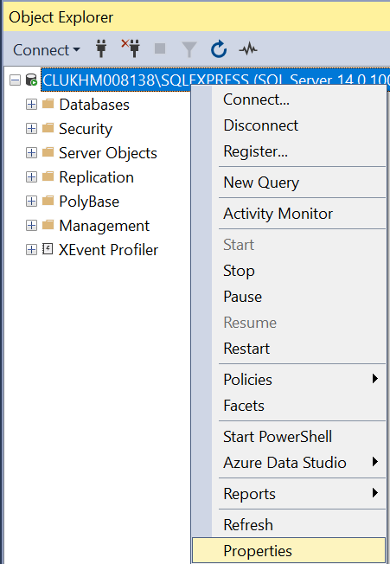
- Select Security.
- Select SQL Server and Windows Authentication mode.
- Click OK.
- Close SSMS because you're going to make more changes.
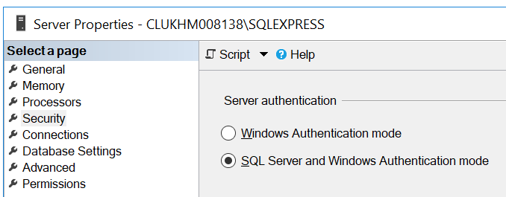
- In Windows, type the word compmgmt.msc in the search box.
- This will run the Computer management application.
- Select 'Services and Applications' > 'SQL Server Configuration Manager'.
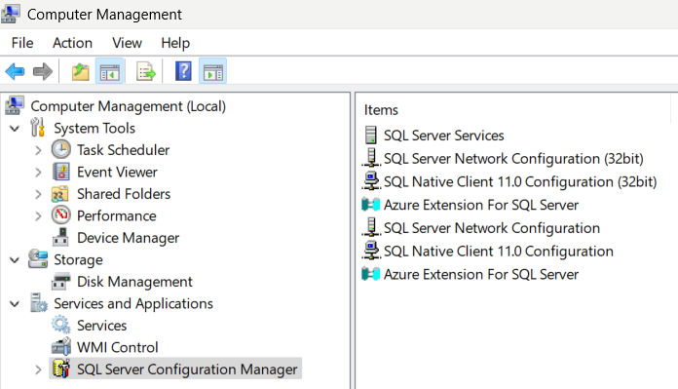
- Double click the SQL Server Network Configuration menu.
- Double click the Protocols for SQLEXPRESS (on the right-hand side).
- Double click the TCP/IP menu from the right-hand side.
- Double click on the Enabled dropdown list to change its state to Yes.
- Click on the IP Addresses tab.
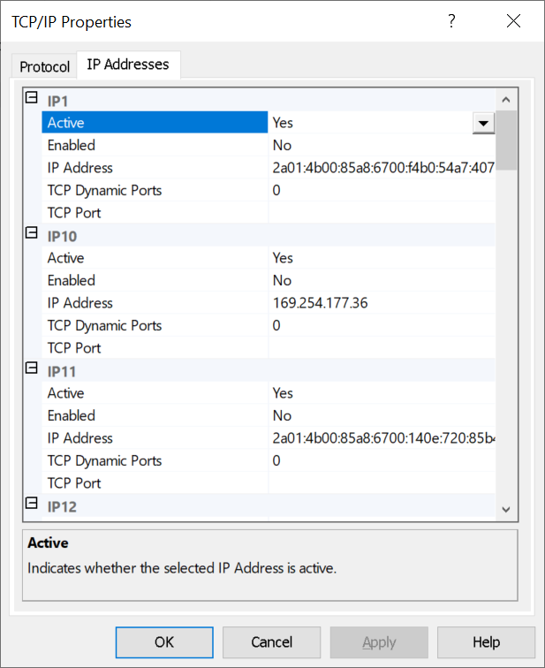
- Scroll to the bottom of the list and take a note of the IPAll TCP port 1433
(could be different) which you'll need when you construct a connection string in your Java code later on.

Restart the SQL Service
- In windows, type services or find Services from the same Window where you set up the protocols above.
- Find the SQL Server service and restart it
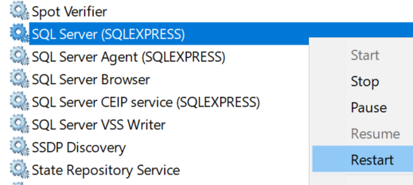

Create a user in SSMS
Next we'll create a user for your application with enough rights to access a database of your choice.
- Create a new login by right- clicking on the Security tab.
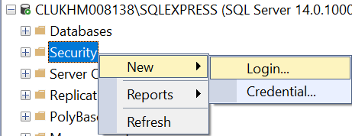
- Select the ‘SQL Server authentication’ radio option.
- Type the user details (like bob, password123) and uncheck 'User must change password at next login'.
(This is just to make this lab simpler. Normally, you want the user to change password.)
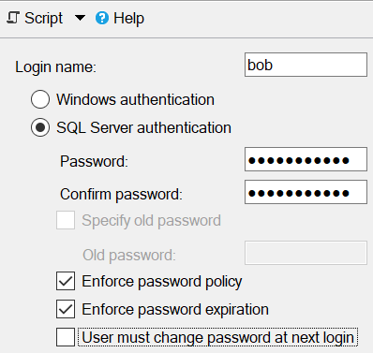

- Grant rights by selecting the ‘User Mapping’ item on the left.
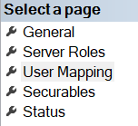
- Select the qastore database and assign as many rights as needed.
Here we've selected db_owner rights but in real life you may select fewer rights.
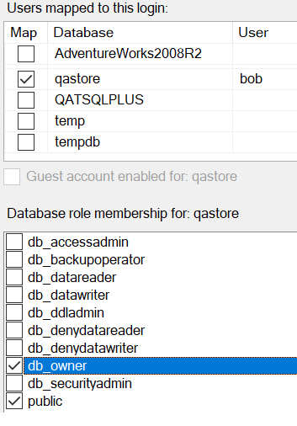
- Click OK.
- Disconnect and reconnect the database using these buttons. 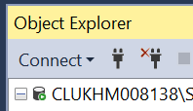
- Try the new user when you connect back again to test the new login.
- You're now ready to use this new user's credentials in code.
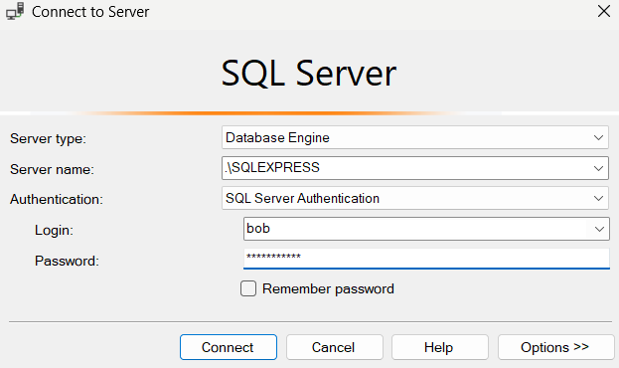

Write the code
In this section you'll extract rows from the qastore database. You'll now need to create a Maven application. Please follow the step-by-step instructions below.

- Start eclipse.
- Start a new Maven project.
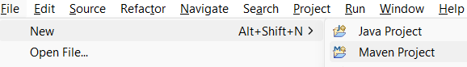
If this option is not visible, choose File > New > Other…
Then type Maven.
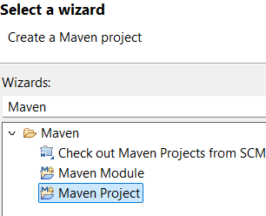
- Select a folder where you want to save your project if you like.
Check this option:
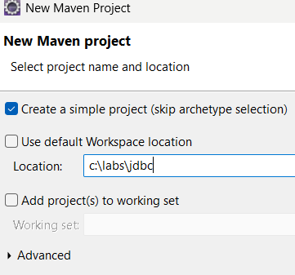
- Type a name for your project and then click Finish.
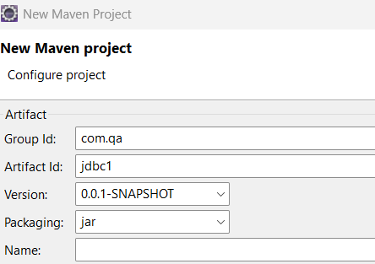
- Type a project name and then click the Finish button.
- Open the pom.xml file from the Package explorer window and type:

<project xmlns="http://maven.apache.org/POM/4.0.0"
xmlns:xsi="http://www.w3.org/2001/XMLSchema- instance"
xsi:schemaLocation="http://maven.apache.org/POM/4.0.0 https://maven.apache.org/xsd/maven-4.0.0.xsd">
<modelVersion>4.0.0</modelVersion>
<groupId>com.qa</groupId>
<artifactId>JSON</artifactId>
<version>0.0.1-SNAPSHOT</version>
<dependencies>
<dependency>
<groupId>com.microsoft.sqlserver</groupId>
<artifactId>mssql-jdbc</artifactId>
<version>12.8.1.jre11</version>
</dependency>
</dependencies>
</project>

(Press Ctrl-Shift-f to format this file.)
Note: The <dependency> section is taken from the Maven repo site here: https://mvnrepository.com/
Just open the site and then search for jdbc.
Scroll down through the results and select:
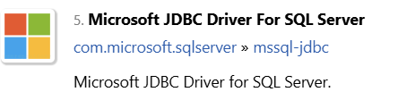
You can then select a version like 12.8.1.jre11
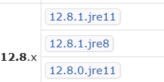

And copy the text for your pom file:
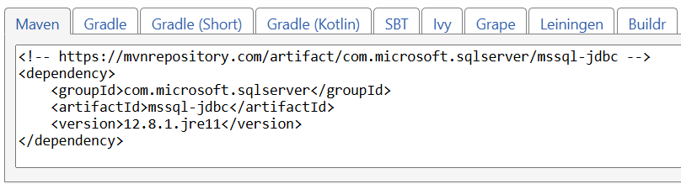

- Make sure all files are saved before running your code.
- Create a class called Program with main() in the node.
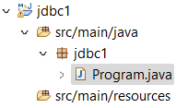

- Type the following code in the Program class:
package jdbc1;
import java.sql.Connection;
import java.sql.DriverManager;
import java.sql.ResultSet;
import java.sql.Statement;
public class Program {
public static void main(String[] args) {
new MSSQLExample().read();
}
}

class MSSQLExample {
public void read() {
String url = "jdbc:sqlserver://localhost\\SQLEXPRESS:1433;databaseName=qastore;encrypt=true;trustServerCertificate=true;user=bob;password=password123";
try (Connection conn = DriverManager.getConnection(url);
Statement stmt = conn.createStatement()) {
String query = "SELECT * FROM sale'";
ResultSet rs = stmt.executeQuery(query);
while (rs.next()) {
System.out.println(rs.getString(1)+ "," + rs.getString(“description”));
}
} catch (Exception e) {
e.printStackTrace();
}
}
}

- Run your code to see it working by pressing Ctrl-F11.

Try more SQL queries
- Try these SQL statements in your code to see how they work:
SELECT emp_no, description FROM sale WHERE emp_no = 60

SELECT emp_no, description FROM sale WHERE emp_no = 60 order by description

- Try using the StringBuilder class:
class MSSQLExample {
public void read() {

String url = "jdbc:sqlserver://localhost\\SQLEXPRESS:1433;databaseName=qastore;encrypt=true;trustServerCertificate=true;user=bob2;password=password123";

StringBuilder out = new StringBuilder() ;

try (Connection conn = DriverManager.getConnection(url); //, user, password);
Statement stmt = conn.createStatement()) {

String query = "SELECT * FROM company where county='London'";
ResultSet rs = stmt.executeQuery(query);

while (rs.next()) {
int id = rs.getInt(1);
String name = rs.getString(2);
out.append(String.format("No: %-7d| Company name:%-25s|\n",id,name) );
}
} catch (Exception e) {
e.printStackTrace();
}

System.out.println(out.toString());
}
}

Create parameterised queries
To safeguard your system against SQL Injection attacks and to ensure well-constructed SQL statements, always use parameterised queries. In the previous example, the value 'London' was directly inserted into the SQL string, which is not recommended. Instead, consider using the following parameterised approach for improved security and efficiency. This method is particularly helpful when working with multiple parameters. Please review and run the provided code.
class MSSQLExample {
public void read() {

String url = "jdbc:sqlserver://localhost\\SQLEXPRESS:1433;databaseName=qastore;encrypt=true;trustServerCertificate=true;user=bob2;password=password123";

StringBuilder out = new StringBuilder() ;

try (Connection conn =
DriverManager.getConnection(url);
Statement stmt = conn.createStatement()) {

String sql = "select company_no, company_name, post_code, county " + "from company WHERE county=? AND post_code like ?" ;
PreparedStatement ps = conn.prepareStatement(sql) ;
ps.setString(1,"London"); // the first ? (city)
ps.setString(2,"N%"); // second ? (contactName)

ResultSet rs = ps.executeQuery();

while (rs.next()) {
int id = rs.getInt(1);
String name = rs.getString(2);
out.append(String.format("No: %-7d| Company name:%-25s|\n",id,name) );
}
} catch (Exception e) {
e.printStackTrace();
}

System.out.println(out.toString());
}
}

More challenges!
Now try inserting a new row into the customers table.
Hint: Use the statement's executeUpdate() method.
Try to update the row which you just created.
See if you can delete a row.
** End **



